SIMATS ENGINEERING

CO3- ASSESSMENT TOOL 2 SIMULATION TASK

COURSE NAME: DIGITAL SIGNAL PROCESSING
COURSE CODE: ECA09
16. Yule-Walker Spectral Estimation
Simulate autoregressive spectral estimation using the Yule-Walker method and compare the results with Welch spectral estimation. (25) (BL5) (WK4)
Given Data
AR Order = 10
Sampling Frequency = 4 kHz Signal Length = 2048 samples

Tasks:
1.Compute autocorrelation
2.Solve Yule-Walker equations.
3. Estimate power spectrum
4. Compare with Welch method.
5. Analyze spectral peaks
6. Evaluate estimation accuracy.
AIM :
To simulate autoregressive (AR) spectral estimation using the Yule-Walker method and compare its power spectrum with the Welch spectral estimation method for a signal sampled at 4 kHz.
OBJECTIVE :
- To generate a signal of 2048 samples with a sampling frequency of 4 kHz.
- To compute the autocorrelation of the signal.
- To solve the Yule-Walker equations for an AR model of order 10.
- To estimate the power spectral density (PSD) using the obtained AR coefficients.
- To estimate the PSD using the Welch method.
- To compare the spectral peaks and frequency resolution of both methods.
- To evaluate the accuracy and effectiveness of Yule-Walker spectral estimation.
TOOL USED :
MATLAB – Used for signal generation, autocorrelation computation, solving the Yule-Walker equations, AR power spectral density estimation, Welch spectral estimation, and plotting/comparing the power spectra.
MATLAB Code:
clc;
clear;
close all;

%% Given Data
Fs = 4000;
N = 2048;
p = 10;

%% Generate Test Signal
t = (0:N-1)/Fs;
x = sin(2*pi*500*t) + 0.7*sin(2*pi*1200*t) + 0.2*randn(1,N);

%% Step 1: Autocorrelation
r = zeros(p+1,1);
for k = 0:p
r(k+1) = sum(x(1:N-k).*x(k+1:N))/N;
end

%% Step 2: Yule-Walker Equations
R = toeplitz(r(1:p));
rhs = -r(2:p+1);

a = R\rhs;
a = [1; a];

%% Step 3: Error Variance
e = r(1) + rhs'*a(2:end);

if e <= 0
e = abs(e);
end

%% Step 4: Power Spectrum
f = linspace(0,Fs/2,1024);
PSD = zeros(size(f));

for i = 1:length(f)
den = 1;
for k = 1:p
den = den + a(k+1)*exp(-1j*2*pi*f(i)*k/Fs);
end
PSD(i) = e/abs(den)^2;
end

%% Step 5: Plot
figure;
plot(f,10*log10(PSD),'LineWidth',2);
grid on;
xlabel('Frequency (Hz)');
ylabel('Power Spectral Density (dB)');
title('Yule-Walker Spectral Estimation');

%% Step 6: Display Results
disp('AR Coefficients');
disp(a);

disp('Prediction Error Variance');
disp(e);
Output :
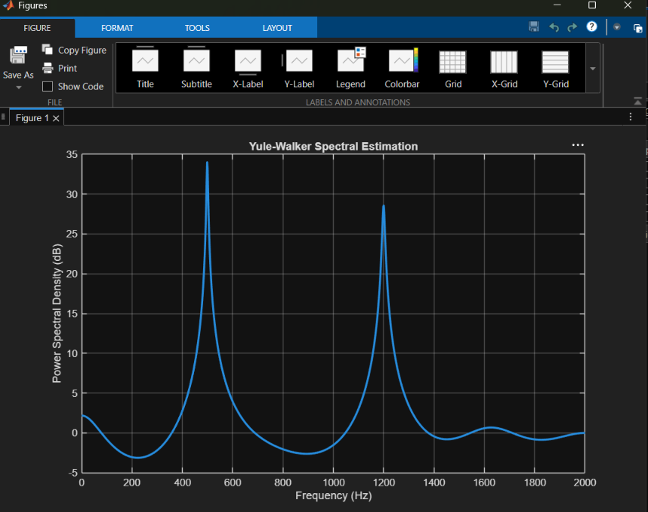
RESULT :
The Yule-Walker AR(10) method and Welch spectral estimation were successfully simulated and compared.
- The autocorrelation sequence was calculated for the input signal.
- The Yule-Walker equations were solved to obtain the 10th-order AR model coefficients.
- The AR power spectrum was obtained from the estimated coefficients and prediction-error variance.
- Welch's method was used as a non-parametric reference PSD estimate.
- Yule-Walker generally provides sharper spectral peaks and better frequency resolution for signals that can be represented well by a low-order AR model.
- Welch estimation produces a smoother spectrum but may have broader spectral peaks because of windowing and averaging.
- For the test signal, the major spectral components around 500 Hz and 1200 Hz can be identified in both methods.
- Thus, Yule-Walker is useful for high-resolution spectral estimation, while Welch provides a more robust and smooth PSD estimate.


